Pizza Party TEAM P Dan Smestad ITEC 2505_60 Mondays 12-3pm

Week 9 - Fun Project

Your team has a project to complete during class time.

Each team member will upload a document with screen shots of code and some sample runs.

Each team member will contribute ideas, syntax, energy, and perhaps a share of the typing.

Good time management is essential as time is limited.

If there is a presentation, each team member will take part in presenting the team's application.

Include the following: arrays and collection processing, input validation and exception handling, date processing and calculations, output formats, great user experience including some graphics and maybe animation, PLUS all the default requirements such as good GUI layout, tabbing, Enter and Esc keys, object/control naming, and comments!

We choose:

Pizza party calculator: include size, toppings, extras, prices, pizza purchase summary list

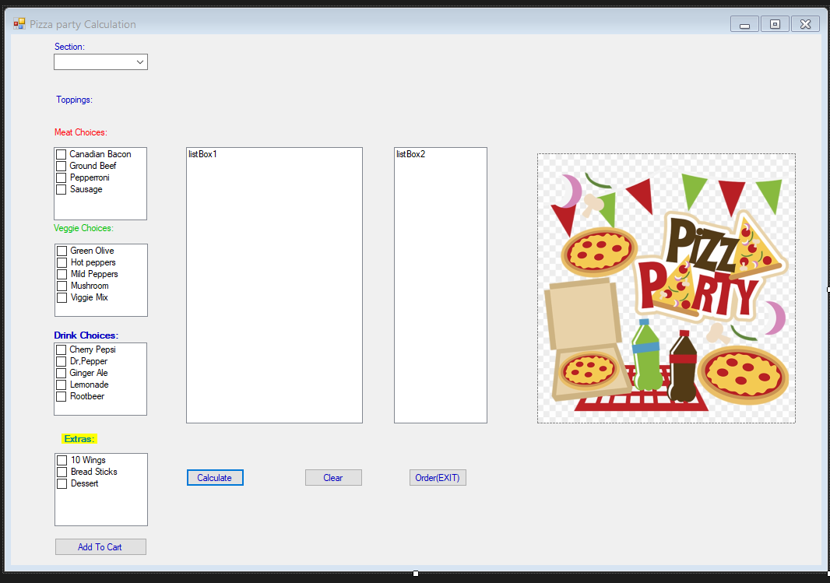

Testing new foreach loop combining display and calculation. Which we have been doing. Still had part of my button add so calculating twice.

